**Assignment 1: Pseudocode and Flowchart for Sorting Algorithm - Write  
pseudocode and create a flowchart for a bubble sort algorithm. Provide a  
brief explanation of how the algorithm works and a simple array of integers  
to demonstrate a dry run of your algorithm.**

**Algorithm:**

1)Get the value of n (length of array)

2)Take the first element and compare it with the immediate next neighbour to the right of it.

Aj>Aj+1

If True then swap and increase the value of j by 1.

If False then increase the value of j by 1.

3)Repeat step 2, n-1 times

**Pseudo Code:**

**While i<n**

**For j=0 to n-1**

**If a[j]> a[j+1]**

**Then**

**Swap()**

**End**

**j=j+1**

**end**

**Flowchart:**

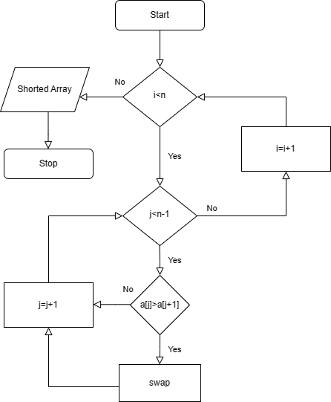

**Dry Run:**

Unsorted array: 9 5 4 3 7

Compare 9 and 5 as 9>5 so, we will swap it

5 9 4 3 7

Now, compare 9 and 4 as 9>4 so, we will swap it

5 4 9 3 7

Again,compare 9 and as 9>3 so, we will swap it

5 4 3 9 7

Again,compare 9 and 7 as 9>7 so, we will swap it

5 4 3 7 9

Again, compare 5 and 4 as 5>4 so, we will swap it

4 5 3 7 9

Again, compare 5 and 3 as 5>3 so, we will swap it

4 3 5 7 9

Again, compare 5 and 7 but 5<3 so, number after 5 is shorted and we have start again

And now, compare 4 and 3 as 4>3 so, we will swap it

3 4 5 7 9

Again, compare 4 and 5 but 4<5 so, number after 4 is shorted.

Hence we get our shorted array